Trevor Scott
Returning Officer and
Electoral Registration Officer
Wealden District Council, Vicarage Lane, Hailsham, East Sussex, BN27 2AX
T 01892 602417
E elections@wealden.gov.uk W www.wealden.gov.uk
OUR REF:

ASK FOR: Heather Blanshard

DIRECT DIAL: 01892 602407

DATE: 07 February 2023

YOUR REF:

Mrs Rosie Barnes (Clerk to Frant Parish Council)
4 Coller Mews
Rotherfield Road
Crowborough
East Sussex
TN6 3BW

Dear Mrs Barnes (Clerk to Frant Parish Council)

Casual Vacancy
Parish of Frant (Bells Yew Green)

Thank you for advising me of the casual vacancy that has arisen on your Council.

Please find enclosed two copies of the Notice of Vacancy and I shall be grateful if you could arrange for at least one to be displayed in a prominent position no later than the date shown on the Notice. Please email elections@wealden.gov.uk to confirm that the Notice has been displayed by the date shown.

Please let me know if your Council co-opt to fill the vacancy and forward a copy of the Acceptance of Office and Register of Interests forms.

I am grateful for your assistance in this matter.

Yours sincerely

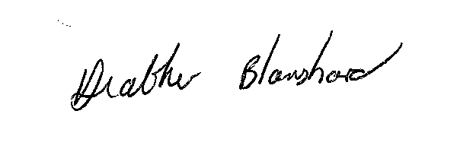

Heather Blanshard
Electoral Services Manager

NOTICE OF VACANCY
IN OFFICE OF COUNCILLOR

PARISH OF FRANT (BELLS YEW GREEN)

NOTICE IS HEREBY GIVEN

that due to the resignation of Deborah Anne Park, a vacancy has arisen in the Office of Councillor for the Parish Council.

In accordance with Rule 5 (6) of The Local Elections (Parishes and Communities) (England and Wales) Rules 2006, where the vacancy occurs within six months before the day on which the councillor whose office is vacant would regularly have retired, an election shall not be held and the vacancy may be filled either by co-option by the Frant (Bells Yew Green), or at the next ordinary election of councillors on Thursday.4 May 2023.

Dated 6 February, 2023

Trevor Scott
Returning Officer
The Elections Office
Wealden District Council
Vicarage Lane
Hailsham
East Sussex
BN27 2AX

NOTICE OF VACANCY
IN OFFICE OF COUNCILLOR

PARISH OF FRANT (BELLS YEW GREEN)

NOTICE IS HEREBY GIVEN

that due to the resignation of Deborah Anne Park, a vacancy has arisen in the Office of Councillor for the Parish Council.

In accordance with Rule 5 (6) of The Local Elections (Parishes and Communities) (England and Wales) Rules 2006, where the vacancy occurs within six months before the day on which the councillor whose office is vacant would regularly have retired, an election shall not be held and the vacancy may be filled either by co-option by the Frant (Bells Yew Green), or at the next ordinary election of councillors on Thursday 4 May 2023.

Dated 6 February, 2023

Trevor Scott
Returning Officer
The Elections Office
Wealden District Council
Vicarage Lane
Hailsham
East Sussex
BN27 2AX

