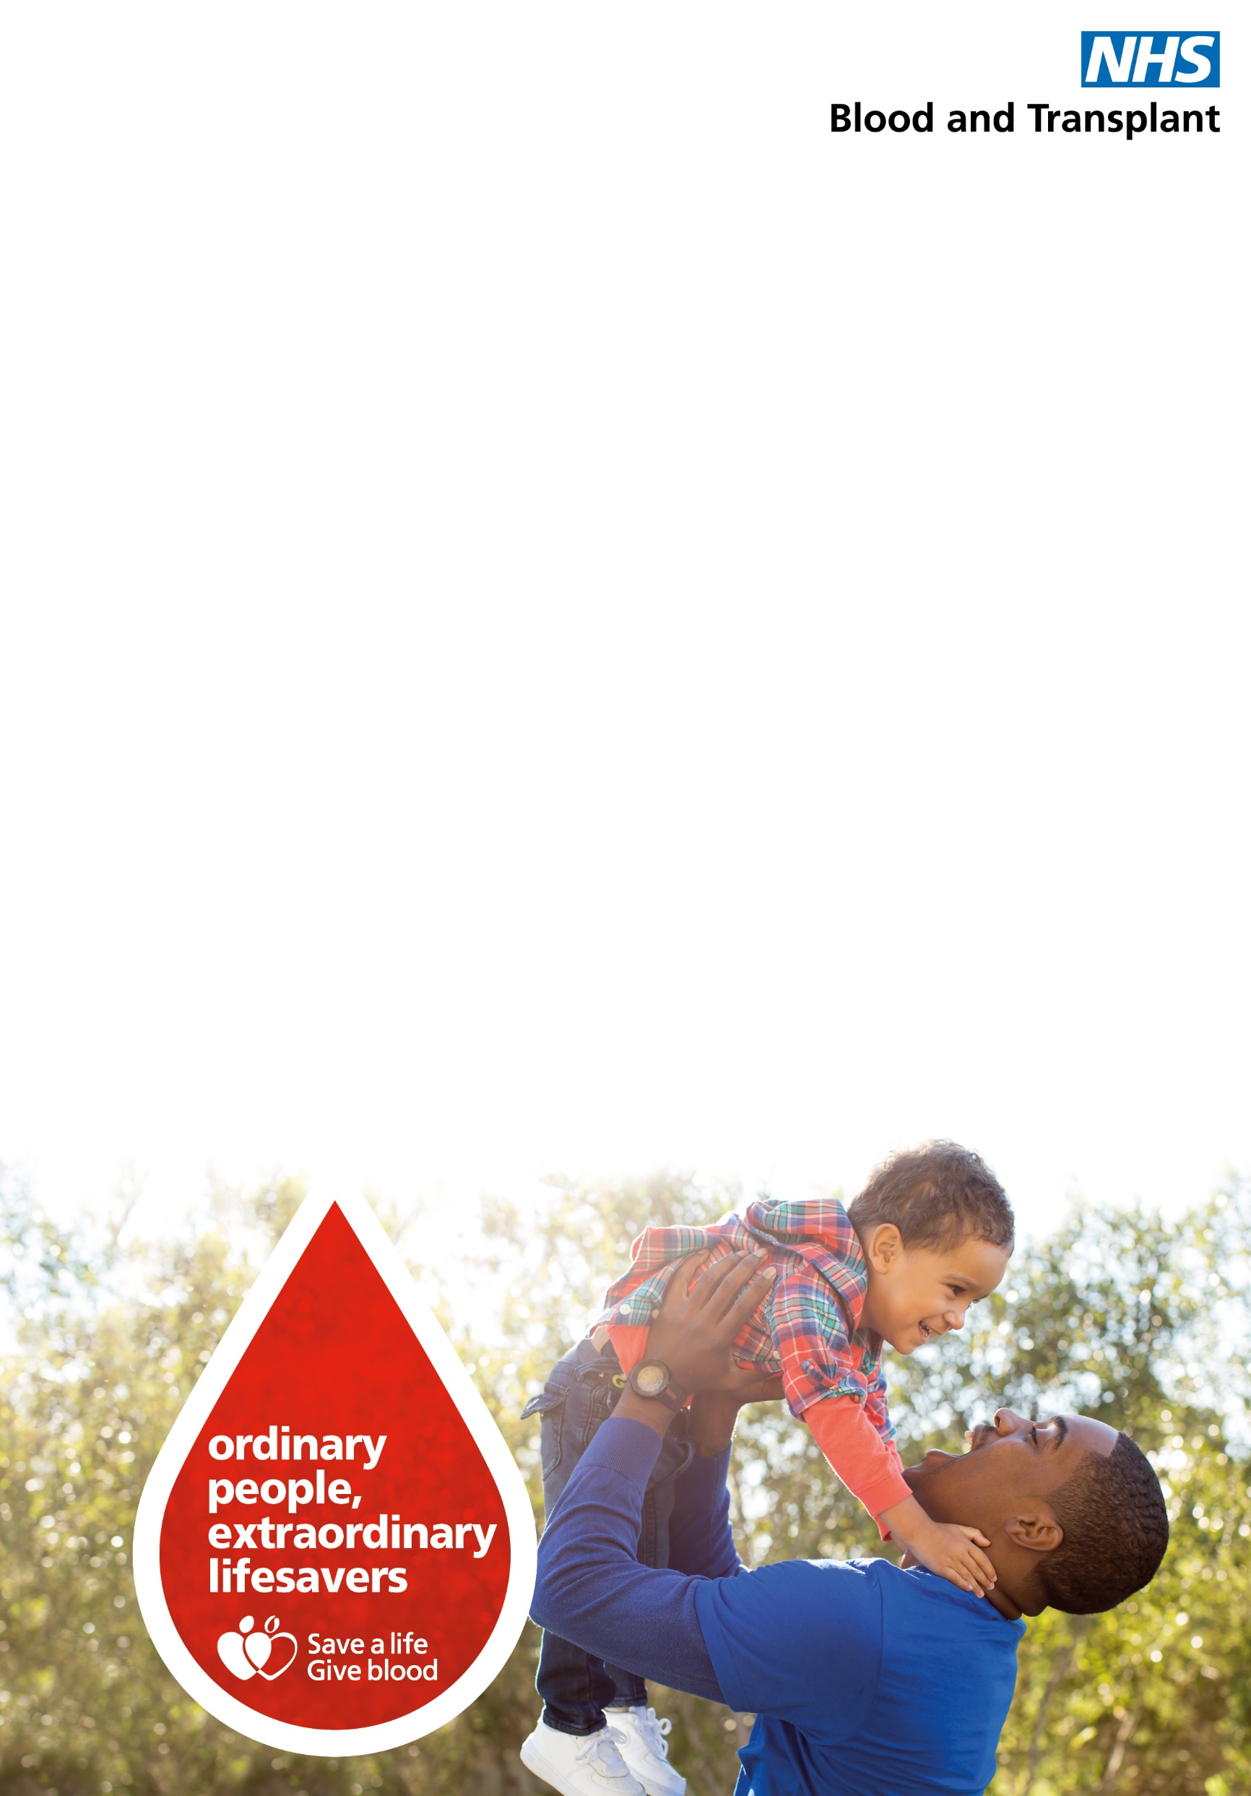

**We are holding extra blood donation sessions**at **The Camden Centre**, Market Square, Royal Victoria, Tunbridge Wells, TN1 2SW on  
Wednesday 24th February and Friday 5th March 2021  
and have appointments available between  
13:45 – 19:45

**To book an appointment**

* **visit us at blood.co.uk**
* **download our app NHSGIVE BLOOD**
* **call us on 0300 123 23 23**

We have extra measures in place for the safety of our staff and donors so ask that you come alone to session and, where possible, do not bring children at this time.

